Task No 01: Draw UML Diagram for Online Shopping System using Use Case Diagram.

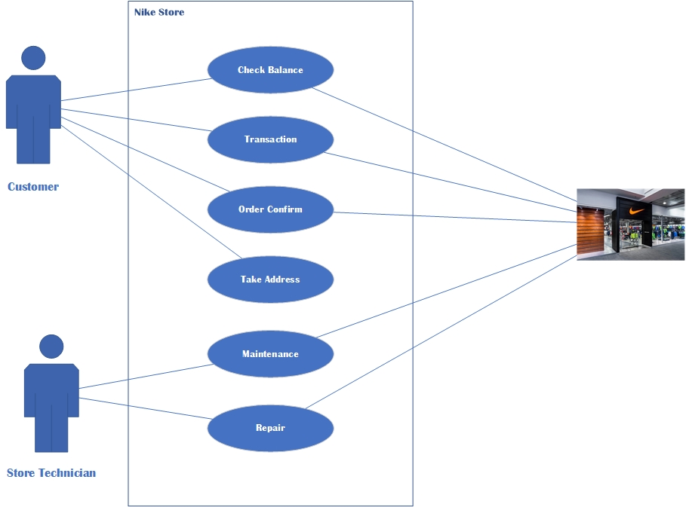

Task No 02: Draw UML Diagram for Online Shopping System using Activity Diagram.

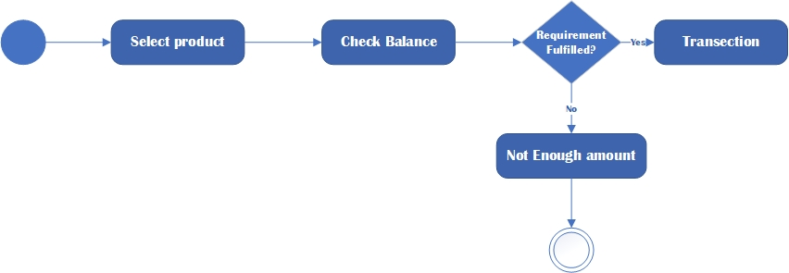
Task No 03: Draw UML Diagram for Online Shopping System using Sequence Diagram.

